
`

TYPE CLUB NAME HERE

WELCOME 4
OUR CLUB 5
WHERE TO GO AND WHAT TO DO THE FIRST TIME AT THE CLUB 6
OUR TRACK 6
Track Access 6
OUR CLUB FACILITIES 7
Parking 7
Access 7
Out Grid/In Grid 7
Pit/Paddock 7
Noticeboard 7
Karting Activity/Private Practice 8
Club Days 8
Clubrooms / Clubhouse 8
Alcohol 9
Canteen 9
Underage Driving 10
Toilet Amenities 10
Animals 10
Facility Map 10
Communication 11
Communication Platforms 11
VOLUNTEERING 12
Working With Children Checks 12
Officiating 13
Committee 13
Bar 14
Canteen 14
Other roles 14
GET STARTED IN KARTING 15
Drivers Briefing 15
Australian Karting Manual 15
Kart Racing Numbers 16
“P” Plates 16
PROTECTIVE CLOTHING 17
LICENCING 19
Licences 19
Licence Categories 19
How to Apply 19
Participant’s Licence 20
EVENTS 24
Club Championship Trophies/Awards 24
Social 24
RESPECT KARTING 25
What does this mean for you? 25
Child Safety 26
SUPPORT OUR SUPPORTERS! 29

WELCOME

Hello!

On behalf of the (insert club name) (insert club abbreviation i.e. KAKC), I wish you a very warm welcome. We are really looking forward to your involvement in our Club.

We always aim to be helpful and approachable in assisting you in your karting journey, whether you are just starting out or looking to take your karting further. We pride ourselves on being a Club for all types of karting enthusiasts, from beginners through to competition drivers, and everything in between.

Our Club will support you in your karting experience by providing access to driving activities, karting instruction and social engagement within the karting community. We look forward to watching you enjoy your karting experience with our Club.

As a member of (insert club abbreviation), we encourage you to follow your own journey within the sport, through our many different pathways, including participating, officiating, and volunteering. To assist you, we provide social karting practice sessions, club days, state and national events. We know you can find your karting obsession within our Club.

The (insert club abbreviation) handbook is designed to provide you with a brief overview of the club and general information to assist with your membership it does not replace or override any Rules and Regulations that form part of your karting participation. Our sport is governed by specific Rules and Regulations to ensure the safety of our participants, so we have designed this handbook to be an easy “go-to-guide” in order to make the most of your transition to karting and our Club a lot simpler.

We want to grow opportunities for people to participate in the Club, on and off the track. Without the assistance of our members and community our Club would not exist, so if you are able to assist in any manner, please let one of our committee members know.

Stay connected on our (insert club abbreviation) website, Facebook, and Instagram pages [Insert Club Social Media URL’s] where you will be able to find club information, the latest news and updates on our great Club and members.

Once again welcome to (insert club abbreviation), we hope this will be the beginning of a very long relationship with our Club.

(President Name/Signature)
(insert club abbreviation) President

OUR CLUB
(Insert club abbreviation) is a voluntary not-for-profit organisation, which simply means that none of our Management Committee members are paid to fulfil their roles within the Club. To assist in sharing the workload, and to ensure our club remains viable for years to come, we ask all members contribute in some way towards the running of the Club.

Contributions can include becoming a committee or subcommittee member, supporting Club operations via officiating, maintenance of facilities, assisting with events, etc. We’re sure that you will have a great time with like-minded people at our club when undertaking these roles.

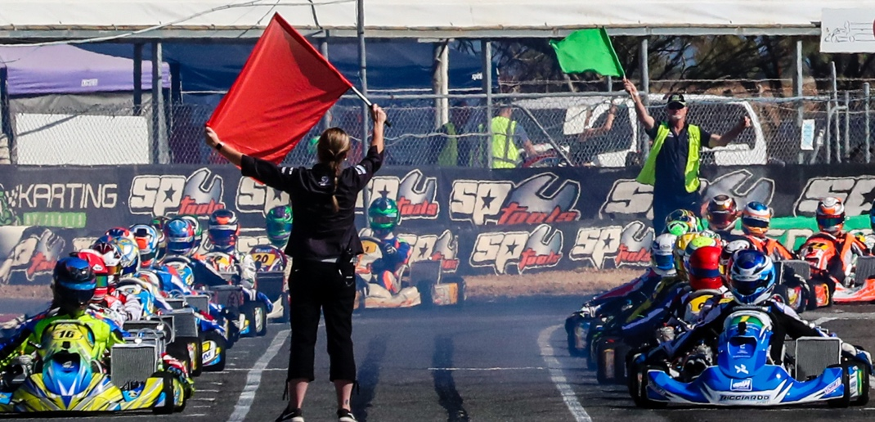
Officials are a crucial component of karting, regardless of whether you are social karting, competing at club events or racing in state and national championships. We offer structured competition racing and recreational (social) karting activities. Both competition and recreational karting are supervised for your safety.

We encourage all parents/guardians and drivers to consider the officiating pathway to ensure we can continue to operate within national guidelines for karting. Junior Officials can start their officiating journey at 14 years old!

This is your club, and all help is appreciated. Please keep all shared facilities in a clean, tidy, and operational condition. If you see something that requires attention, please let us know so it can be assessed by the club committee. (Insert club abbreviation) will communicate to members when a joint initiative is required to assist in the upkeep of our facilities. This is a great way of keeping our club in working order as well as giving you an opportunity to get to know your fellow club members better.

Club race days can be long, intensive days. We appreciate you may have to travel to get to our club and to other events, but we want to let you know the travel is worth it. Keep an eye out for and enjoy some of the social activities we host as a club, as well as those we offer with other karting clubs in our community.

We are interested in receiving your feedback on the club and club operations, so stay updated for information regarding our club meetings and AGM’s which are notified on our social media platforms.

WHERE TO GO AND WHAT TO DO THE FIRST TIME AT THE CLUB
(Name of complex) is located at (insert address and description as necessary).


(Insert map if available)

We know starting a new sport or joining a new club can be daunting as well as exciting all at the same time. If you are not familiar with any other club members and would like a little support on your first visits to the club then please come to (insert details of who to meet, where to go, who to advise etc).

If your first day at the club is a practice day you will find every practice session has a Karting Activity Controller, so we recommend letting them know it is your first time at the track so they can help you settle in. If they are busy, they will make sure there is someone else to help make you feel comfortable with your kart and the facilities.

OUR TRACK
For your safety and the safety of other members NO participants may utilise the track at any time without a minimum of a Karting Activity Controller in attendance. You must have a current membership with our club, and have a Karting Australia licence, to be covered under Karting Australia’s insurance, and more importantly to keep everyone safe.

Our track offers great driver challenges, awesome spectator viewing as well as a safe learning experience for our beginner licenced drivers.
(Provide description and picture of track)
- Distance/width/approval rating
- Max Kart number allowance
- Clockwise/Anticlockwise capabilities
- Track access
- Track guidelines
- Public Holidays

Track Access

Access to our track is via the front gate using (key access/remote pin/keyless entry – include app requirements etc). On club days you will find this gate is already open, as the facility is being prepared for the days racing.

Just remember it is important, when accessing our facility, especially for practice that the club guidelines are also completed. These include:
(Enter any club requirements i.e. online ticketing, practice log book, key issue details/ lost and damaged keys/ lock changes)

If you arrive at the track for practice, it is essential that track practice sessions are supervised by a Karting Activity Controller or Level 4 or higher Official before you can use the track.

OUR CLUB FACILITIES
Our club is your club, and we want you to feel as comfortable as possible when attending our facilities, which include our racetrack and associated grid areas, toilet amenities, first aid room and the club canteen (add or delete as necessary).

Parking

Parking is available on site at (add details), as well as at vantage sites around the perimeter of the track. Please ensure your vehicle does not obscure or create a hazard for other vehicles or pedestrians wishing to access the facility. No cars are to be parked on or near the pit area.

Access
Access to our track is available for recreational/social/practice and racing days. We will notify you on practice availability through
- how
- when
- times
- posted via socials
- keyless lock
- contact person for pin access
- KAC/Lv4 roster etc

Out Grid/In Grid

For the safety of all participants, when entering the track proper, you must enter the track via the out-grid area, ensuring you move onto the track during a zero or low traffic situation. After completing your time on the track all karts must exit track via the in-grid area at a slow speed.

Refuelling or oiling chains on the track or within the grid areas is strictly prohibited and will not be tolerated under any circumstances.

Pit/Paddock
The Pit/Paddock is where you work on your kart between races. Our club has a dedicated pit paddock for the use of members. Please use bins provided to keep this area clear of debris. All vehicles must observe the 5km/h speed limit. Please note that any activities including BBQ’s, open fires, smoking, consumption of alcohol and illegal drugs is prohibited in this area.

Noticeboard
Important club messages for members will be posted on the club notice board which is situated (insert location). It is important to always check the notice board before undertaking any activity to ensure members are up to date with any club, state association or Karting Australia requirements. Copies of any current regulations governing track activities including practice sessions will be posted on the noticeboard.


Karting Activity/Private Practice
Any non-competitive activity organised under an Organising Permit must be supervised by a Karting Activity Controller (KAC) or Level 4 or higher Official. This is a compulsory requirement to ensure the club and members are covered by Karting Australia’s insurance policy. These types of activities include general (private) practice and training.

KAC or Officials must:

Complete the online Social Karting Activity Officials Update Form by either CLICKING HERE (link: https://www.karting.net.au/administration/forms) or by scanning the QR Code found on the noticeboard.

Complete the Organised Social Karting Activity Track Check List by CLICKING HERE (link: https://www.karting.net.au/administration/forms) prior to commencing the activity – or check with your club to access hard copies of these forms) .

All licenced drivers must complete the online Social Karting Activity form prior to going on track by CLICKING HERE (link: https://www.karting.net.au/administration/forms) or by scanning the QR Code found on the noticeboard.

Club Days
(Insert club abbreviation) Club Days are designed to provide all members an opportunity to compete in race situations in familiar, supportive, and appropriate class levels. We want you to race as much as you can at a club level until you feel ready to compete at some of the regional events. As you become more experienced with your karting there are other opportunities to race at state and national events. No matter how experienced you are we always want you to be involved in our club days as a competitor, official or volunteer.

A calendar of club events can be found here (insert hyperlink).

Clubrooms / Clubhouse
Our clubrooms/clubhouse amenities are available for members and visitors to enjoy on race days. There may be times where the clubrooms/clubhouse is open on practice days depending on availability of the Committee. Amenities also include sheltered viewing area, open viewing areas, toilet facilities, playground, add in any other relevant options.

Please be aware that any children accessing any of our club facilities must always be supervised by an adult.

Alcohol
Our club is governed by Responsible Serving of Alcohol (RSA) regulations, therefore consumption of alcohol by minors is not permitted at any time.

No alcohol is to be consumed in the grid or track areas at any time, nor at any practice sessions. To ensure the safety of our members (insert club abbreviation) has access to a breath analyser and will reserve the right to breath test any drivers, participants, or pit crew at any time.

As we are a family club it is preferred by the (insert club abbreviation) committee that any activities involving alcohol are not commenced until the completion of the last class event.

Canteen


Our canteen operates on race weekends only. On these days we offer hot and cold food, cold drinks, and snacks. (Add in any other menu options) Usual operating hours on race days are (enter details).

(Add in meal availability if applicable)

We are always looking for assistance in the canteen, whether it be serving, packing, or preparation of food items. No experience is required; we will teach you all you need to know. Helping for an hour or two makes a huge difference.

Underage Driving

Any vehicles on (insert club abbreviation) property must be operated by a licensed motor vehicle driver. All Learners must be accompanied by a fully licensed driver.

Toilet Amenities
You will find both female and male toilet and shower facilities on site, with all abilities access or a separate all abilities option.

These amenities are cleaned and maintained by club volunteers, so we appreciate you taking the time to keep them clean and tidy by putting rubbish in the bins supplied. Please let a committee member know if any areas of these amenities need attention or maintenance.

Please be mindful that both children and adults are utilising these amenities throughout the day, so please be respectful and provide appropriate supervision where necessary.


Animals
For the safety of our participants and spectators’ animals are not allowed on site.
Or
Animals are allowed on site if they are restrained and are not allowed in grid or track areas at any times. Please be considerate of other members who may not be comfortable around animals and always clean up after your pet.

Facility Map
For your convenience we have included a map of our facility to assist you in getting around.
(insert facility map)

Communication
We want to be able to talk to you, we want you to talk with us and we want you to share how great karting can be with all your friends and family.
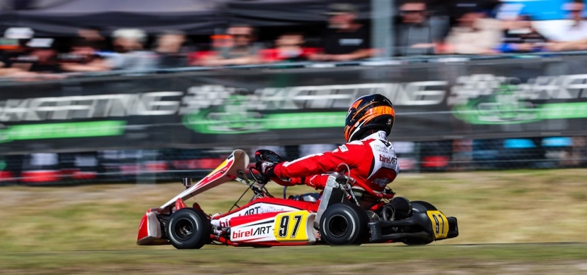
We have several communication platforms that you can join, follow, or view. We want you to like and follow us, share, and tag our club and karting in general relevant posts and while you are there jump on Karting Australia’s social media pages as well.

We want to see you and hear you but remember we need to respect our karting community so don’t say or post anything that may be offensive to anyone in the club or karting.

Communication Platforms
Our social media platforms are (add or delete as necessary):

 | Insert Name of Account and Hashtags Here  #racingstartshere
 | Insert Name of Account and Hashtags Here  #racingstartshere
 | Insert Name of Account and Hashtags Here  #racingstartshere
 | Insert Name of Account and Hashtags Here  #racingstartshere
 | Insert Name of Account and Hashtags Here  #racingstartshere





VOLUNTEERING

As we mentioned we cannot run our club without your help….

We know everyone’s circumstances are different with work, family and competing activities/sports in today’s world. We do not want to add extra stress to busy lives, but we want you to know any help you can provide to our club will always be appreciated. We have plenty of roles, jobs, activities, or tasks that can fit the time you have to make our club a welcoming, organised, and safe space for our members and families.


We welcome all help, of any scope or size, and we have no doubt that we can find a job or task to fit your capability and availability. Many hands make light work in running our club so please contact (add name and contact details or alternatively list some of the contacts for different volunteering spaces in your club) to express your interest.

Working With Children Checks
To be a volunteer within our sport, or any sport, you MUST have a Working with Children Check approved, in your State or Territory, if you are likely to come into contact with children. Good news is, as a volunteer it is FREE to apply.

In most cases we need you to get this card before you start volunteering, so it’s a great idea to get in early and then let us know your card details when you receive it. Just search “Working with Children Card in (enter state)” and our state application portal should become available.

Don’t forget to let us know you are interested in assisting us, even before you get your card. We want to make volunteering as easy as possible for you, so this way we can start getting you ready with any information that can help you upskill or transition into a volunteering role for our club.

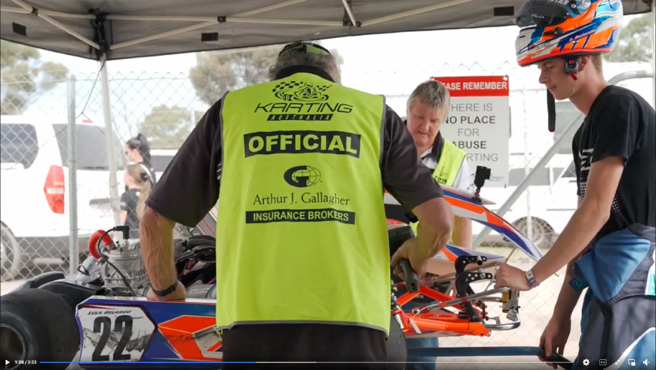
Officiating
Officiating covers so many different roles, some take less time to learn while others are a little more comprehensive. Regardless of the role, we all need to be aware we cannot run our sport without club members been upskilled into these positions. No Officials, No Karting, No Racing.

To assist in the resourcing and training of officials, we have access to the KA Officials Academy (link: https://www.karting.net.au/administration/officials) and we encourage you to register and commence any of the officiating courses that may interest you. The first step on the officiating pathway is the role of Level 5 - Karting Activity Controller (KAC) where you can be accredited to officiate non- competitive activities under an organised permit. Find out more about what you need to do to become a KAC by reviewing the Karting Activity (Recreational) Controller Policy – (click here to download or go to https://www.karting.net.au/administration/by-laws-policies.
If you want to start learning how to officiate race events as well as KAC at a club level, then you can go straight to the Level 4 – Official training.

We are always on the lookout for more people to help in our officiating roles so once your online training is complete, please let us know at the club by contacting (insert name and email / number) and we will arrange to you be rostered on or to shadow an Official to gain some practical experience as an Official at our club.
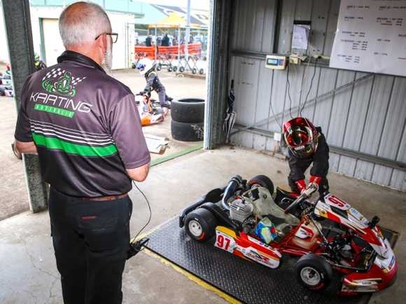
We want you to feel confident and supported in your role, we will do our best to work with you to make that happen.

The more people in our club we can upskill in different roles, will allow us to be more flexible with our Officials and volunteers to suit availability, rather than rely on the same few people who continue to give their time.

Committee
As mentioned, our club is run by volunteers, both on and off the track. Legally our club must be run by a management committee/committee/board in accordance with our club rules. Just like Officials, we have webinar training available, to be done at your convenience, to assist people in understanding the roles and responsibilities of a Committee Member or to learn new skills you may be interested in.

Even if you do not believe you have time to take on a complete role but have an interest in other areas of the club like social media, fundraising, grants, facility development etc please let us know. We can always see what tasks we may have on hand or upcoming that your help would be greatly appreciated with. If this space interests you, please contact (insert name and email/number).

Bar

Our club is fortunate to have its own bar in the clubhouse which is licensed to serve drinks after our race meets. We are always looking for more volunteers in this space. If you (or family members) over the age of 18 are willing to get or has a Responsible Serving Alcohol certification, we would be happy to chat about rostering shifts.

Canteen
Club race days are important to the sustainability of our club and our canteen plays an important role in this. Once again, more hands make light work so if you have a small or larger amount of time on your hands at a meet, than we would love some extra help in the canteen. There are plenty of roles from serving, stocking, and preparing food that may interest you.


Other roles
If we have not mentioned a role that may interest you or you have some expertise in certain areas that may assist the club, we want to hear from you. Please contact (insert name and email/number) so we can arrange a time to chat. We’d love to hear from you about how you might be able to make our club an even better place to be part of.

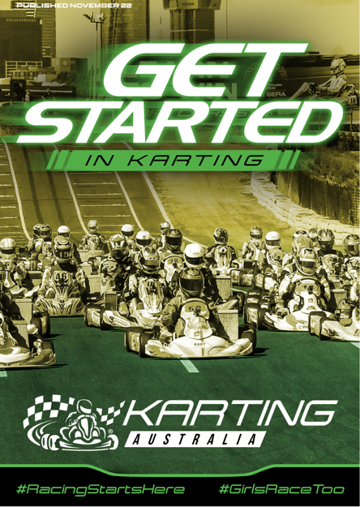
GET STARTED IN KARTING
When you first start out in karting, we understand the rules that govern our sport can be a little over-whelming. To help explain these rules, in an easy-to-follow format aimed at Cadet and Junior drivers, we suggest click to read Karting Australia - Get Started in Karting Information Booklet or alternatively check it out on the Karting Australia website .

Please note this is an unofficial guide and does not carry any regulatory powers. Although, this guide will run you through information about race starts, formation procedures and lots more to help make your entry into racing a little easier. Just remember all your racing rules are found at Karting Australia - Rules.

We have outlined a few points below to help you but remember, we will always have people at the club happy to help you settle into the karting community who can also guide you on what needs to be done. Just ask us!

Drivers Briefing
You will get used to every competition having a driver briefing with the Senior Officials at the start of each day. This is very important as the Race Officials explain the rules of racing and track conditions and/or any changes to the rules for that event.

It is important that drivers and a parent or guardian (if the driver is under 18 years it is mandatory) attend this briefing together.


Australian Karting Manual
For the safety of our members Karting is governed by a strict set of rules to protect not only drivers and their karts but also the integrity of our competitions.

To make this easier, all karting competitions and activities are governed by the same set of rules – the National Competition Rules (NCR). These rules can be found on the Karting Australia (KA) website and are reviewed and updated annually by KA. Additional rules for any club and/or state competitions can be included in State and Supplementary Regulations which are published and displayed at the club, usually on the State and club website and noticeboards.

Kart Racing Numbers
Every kart requires a racing number for competitions and for social karting. Numbers are registered for competitions at the time of submitting your race entry, and no duplicate numbers can be entered. Check plate and number colours and dimensions with your club on available numbers to race at club meets. Race numbers can be purchased from kart suppliers.

When racing at larger events outside of your club, you must also list your number when registering your entry. If someone has the same race number as you, the first person to register for the event with that number will be entitled to race with that number. [Competition Rules, Chapter 1, Rule 11].

“P” Plates

Holders of an 8-Day, D or E licence (including those with specific conditions applied) must display a “P” plate in a location adjacent to their competition number at all times whilst they are on a track. A “P” plate must be used by drivers until they have qualified to be upgraded to the next level of licence. All “P” plates must resemble a “P” plate used by state or territory civil road authorities which can be purchased at auto stores, service stations etc. [see Competition Rules, Chapter 1, Rule 11, Section H AND Chapter 4, Rule 14 ].

PROTECTIVE CLOTHING
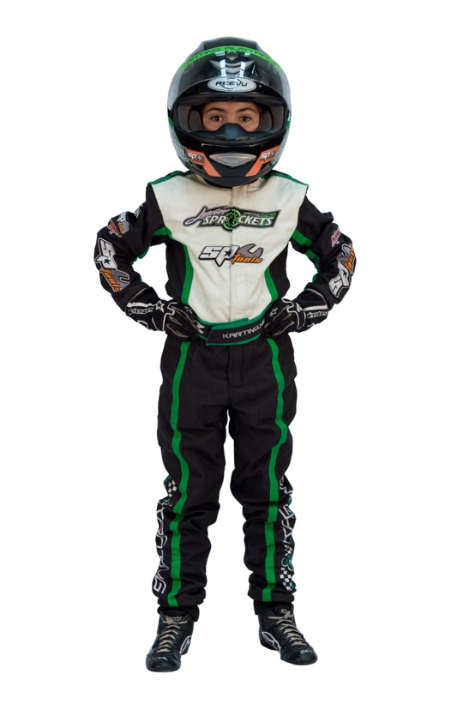
We want your karting experience to be as safe as possible and that includes wearing the correct protective race gear. Sometimes, you can be in a hurry to get on track, but it is always important to make sure your race gear is worn correctly and secured to keep you safe.

Each drive must at all times while driving at kart on a track wear apparel in accordance with the rules. [see Technical Rules, Chapter 7, Section 1].

Most kart shops will also offer a range of safety gear such as full-face helmets, race suits, racing boots, gloves, and other safety gear such as padded rib vests and neck braces. Cadet and Junior classed must wear rib and neck safety protection.

As well as kart shops, motorsport racewear shops carry ranges of karting gear and even motorcycle shops can be good for items like helmets and wet weather driving gear.

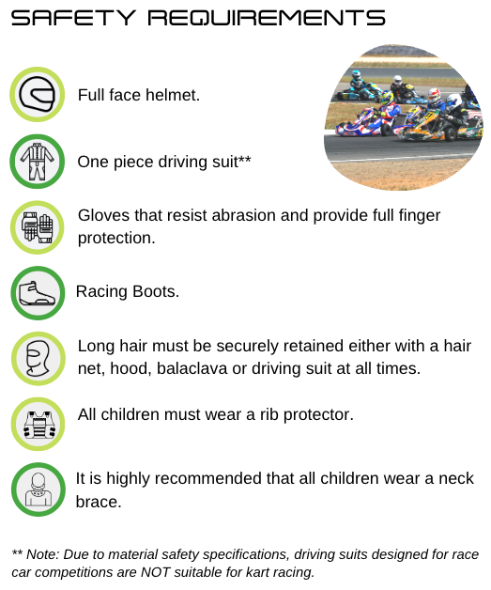

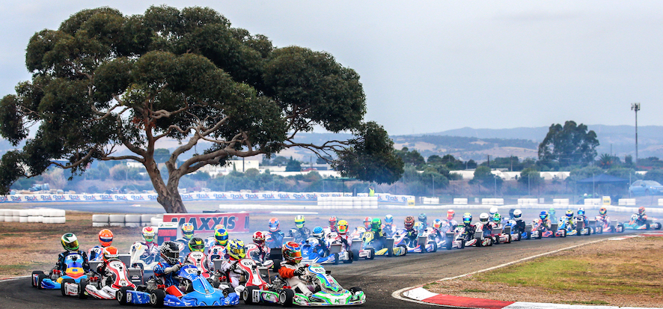
LICENCING

Licences
As mentioned, to drive a kart on a track or participate in a competition, you must hold a current digital driver’s licence issued by Karting Australia in accordance with the NCR. This licence will be used for identification, recording, entry, and confirmation of entry at all meetings.

Licence Categories
All Drivers Licences are divided into four (4) different age group categories, with an extended optional transition time between categories:

- Cadet 9 Licence: 6 to 9 years old. Please note drivers must be 7 years old to compete in a race meeting.
- Cadet 12 Licence: 9 to 12 years old
- Junior Licence: 12 to 15 years old
- Senior Licence: Minimum 15 years

Licence classes A, B, C, D are based on the experience of the driver for different classes. As per our rules new Drivers over the age of fifteen (15) years (‘Senior’) are not permitted to drive a kart with an engine that is more powerful than 125cc - Restricted or 4 Stroke kart.
E licences are issued for six (6) years and up for social and recreational karting only.

How to Apply
If you have not applied for or need to renew your licence these can be done through karting.net.au or through your karting app. Both options will give you access to applications and renewals and if you need any assistance our State Administrator’s are available to help you through the process on 1300 30 KART(5278). Anyone under the age of eighteen (18) years old must also provide a copy of their birth certificate.

Just remember anyone applying for a licence must be a financial member of an Affiliated Club and must remain so for the duration of the licence.

Participant’s Licence
If a driver is under the age of eighteen (18) years old, they must be entered into a competition by their legal guardian - who must be the holder of either a Participants Licence or be over eighteen (18) years old and the holder of a Seniors Competition Licence.

Participant Licences are FREE and can be applied or renewed in the same way as a driver’s licence. Just elect for the “Applying for Participant’s Licence” and follow the prompts.

All Participant’s Licences expire on December 31 each year.

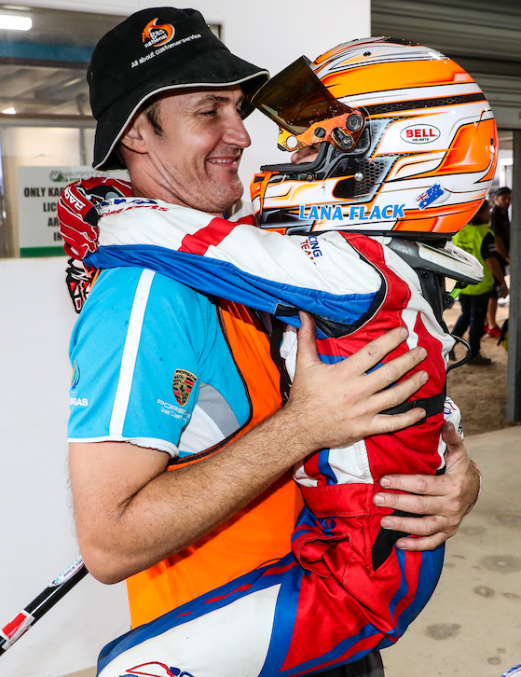

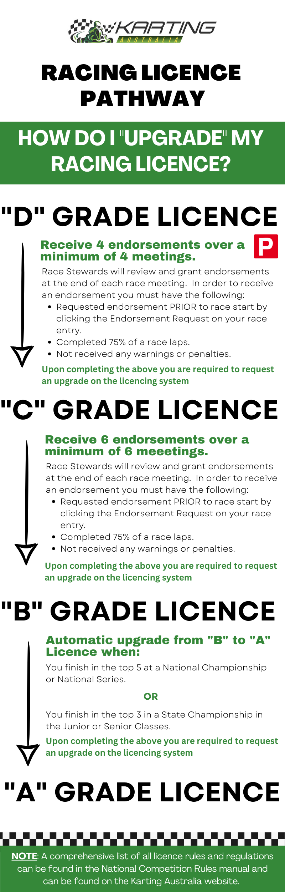

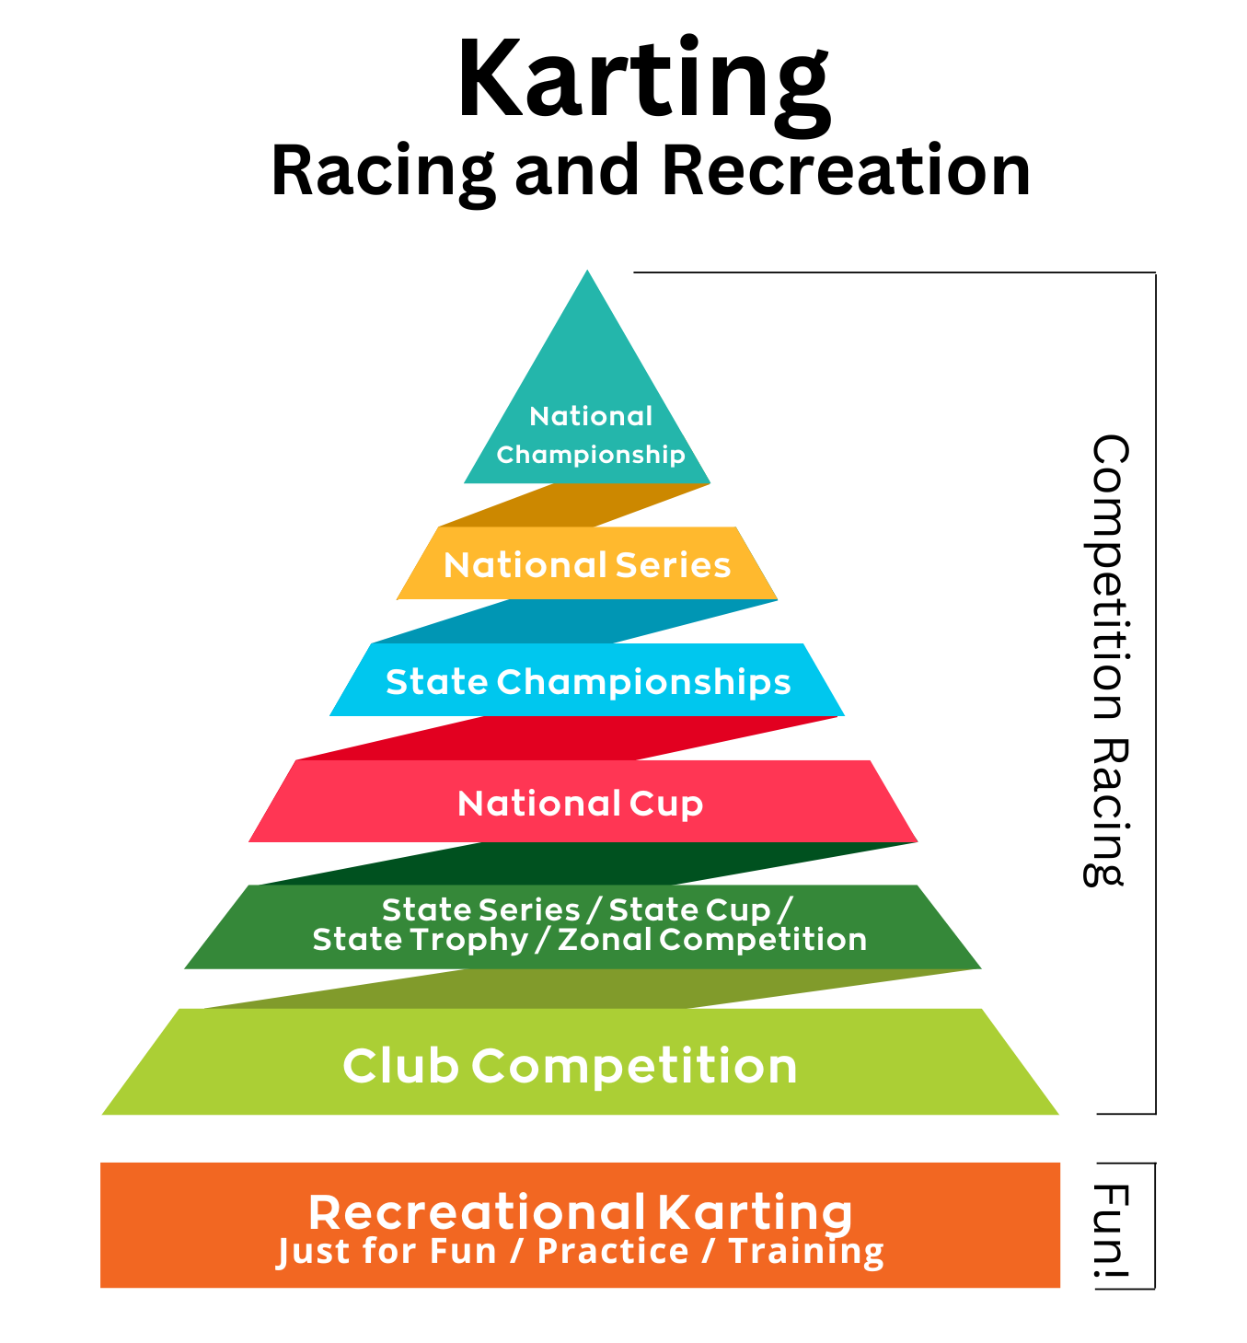

EVENTS

Club Championship Trophies/Awards
We told you club events are important to us. So, even though we believe every member is a winner at our club, we still like to acknowledge those Club Members who have excelled at our club events.

Club day results are used to determine the overall Club Championship Points at the conclusion of the karting season. You must be a club member to qualify for this award.

Trophies and awards are presented at the end of year presentation dinner/afternoon/other, and include:
(Enter relevant club awards)
We also hold a Champion of Champions Race which is a single race held during the last Club Day event of the year for Cadets, Juniors, and Seniors. Trophies are awarded on the day.



Social
Our club is not just about karting …we have just as much fun off the track as we do on it! Keep an eye out for our social events held throughout the year which range from after event BBQ’s, Working Bees, Family activities, Dinners (add or delete as necessary).

If you are interested in assisting with organising any of our social events or have any ideas of new social events, let us know as we always welcome any volunteering assistance on or off the track.

RESPECT KARTING
It is important to our sport that we treat our entire community with RESPECT.

What does this mean for you?
It means you should treat others the same way you like to be treated – with kindness, honesty, sportsmanship, and fairness. We expect all members of our community to communicate in a quiet and calm manner. This may be difficult at times (especially in the heat of a race situation), but it should be noted that we will NOT tolerate any form of abuse towards our officials, drivers, parents, club volunteers or spectators.

All our members should abide by the Karting Pledge:

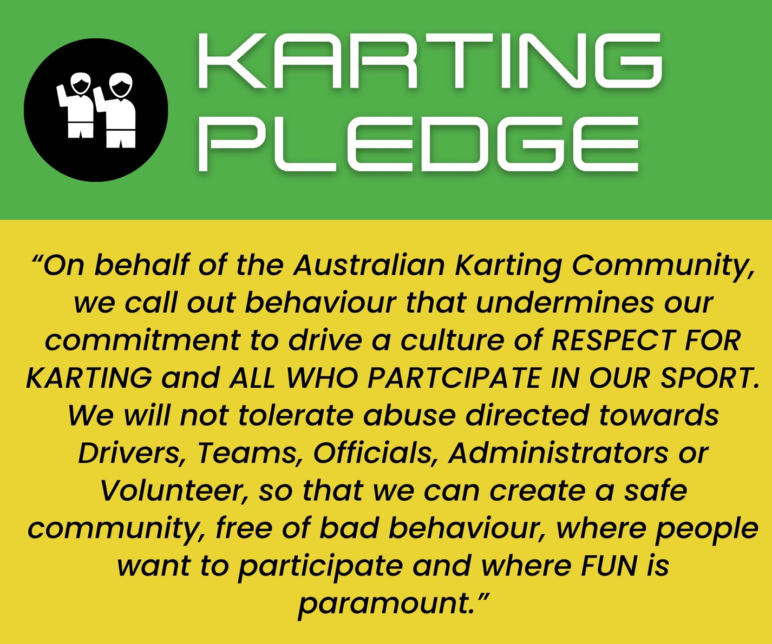

This also means if you witness, or experience behaviour you feel makes you uncomfortable or seems to go against our pledge of respect then we want to know about it. Please report any issues to any of our Club Committee.

Child Safety
Our club has a zero-tolerance policy around child abuse and neglect in any form. We are committed to keeping children safe on and off the track. So, we need your help to do this!

As a valued member of our karting community, you play a crucial role in protecting children in our sport. Legally you MUST know what you should do if you come across, suspect, or basically feel uncomfortable with a situation a child may be in or may potentially become involved in. This includes:

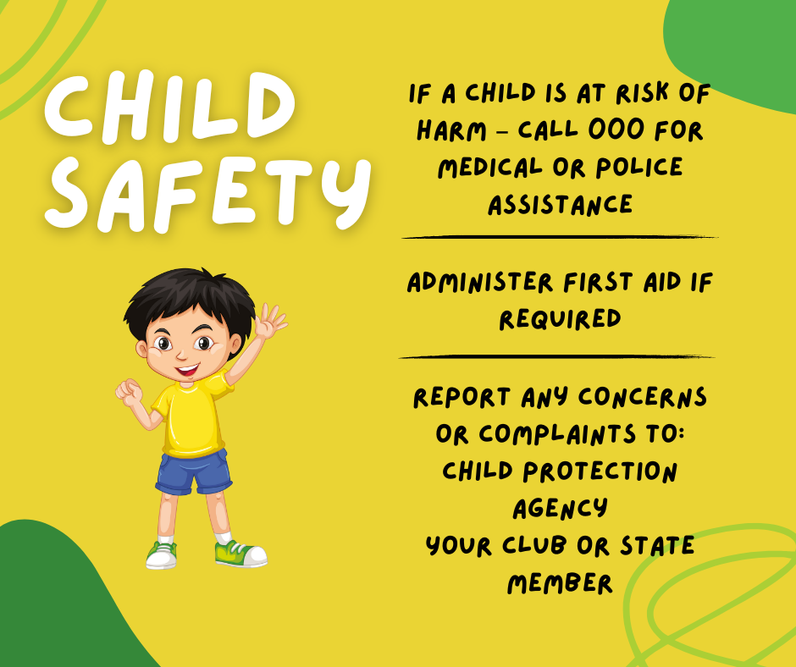
A more detailed policy in dealing with children can be found on the KA website or you can contact our club Member Protection Information Officer/Child Safety Contact on the following (insert club details).

Finally, because we want our club to be child safe, we would like you to read through the safe and unsafe behaviours in karting with your child/ren.

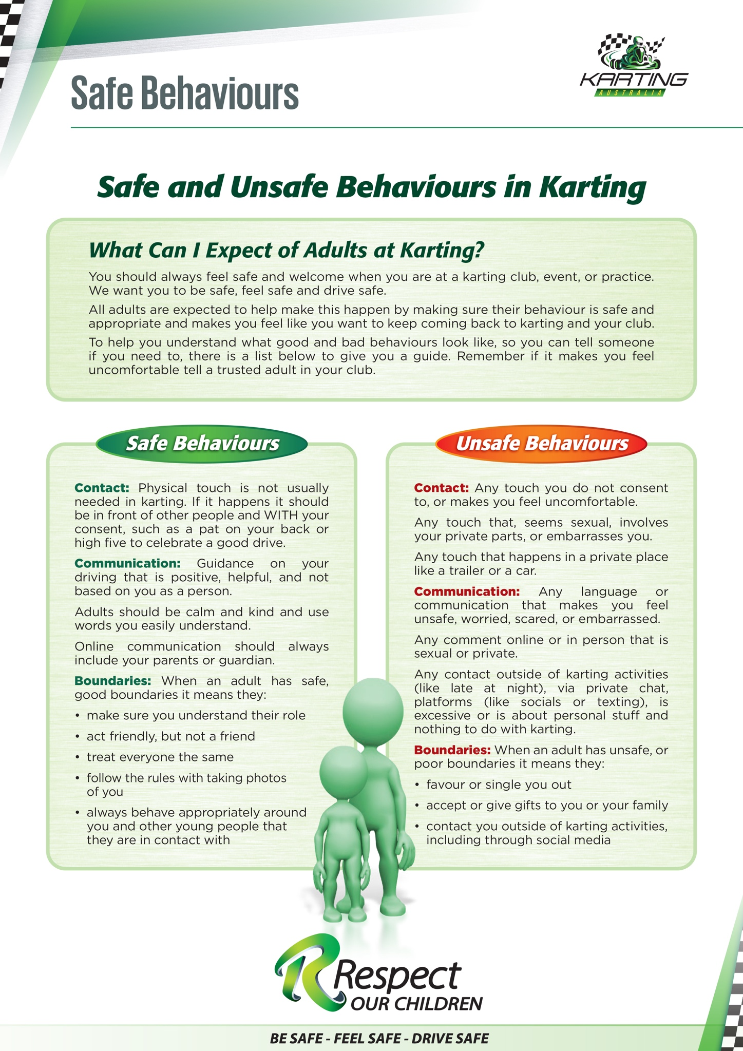
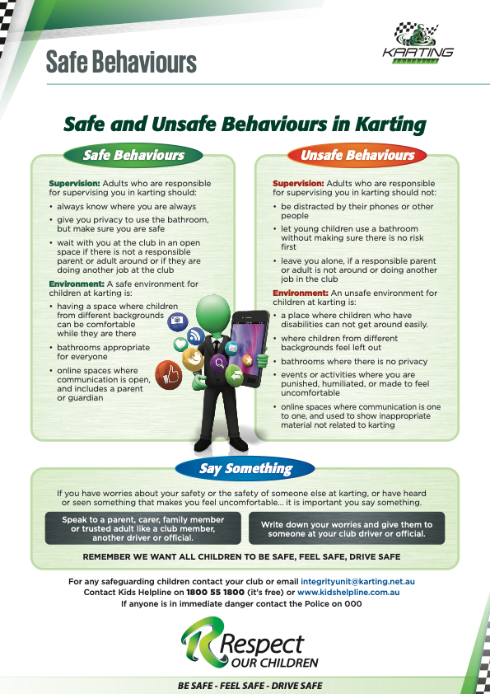

SUPPORT OUR SUPPORTERS!
Finally, we are very committed to supporting our supporters within our club. When you’re looking for a particular product or service, please take the time to check out the options available below. These businesses are all owned by your fellow club members and your support is greatly appreciated.

Insert Club Sponsor Businesses and Logos Here

EXAMPLE


Category:
Name:
Contact:
Phone Number:
Address:
Email Address:
Website

Insert Club Member Businesses Here

EXAMPLE

Name: Company Name
Contact: Contact Name
Phone Number:
Address:
Email Address:
Website:

Category: Retail
Name: Fred’s Bread Shop
Contact: Contact Name
Phone Number:
Address:
Email Address:
Website:

Category: Accountant
Name: Company Name
Contact: Contact Name
Phone Number:
Address:
Email Address:
Website:

Category: Retail
Name: Swimming Pool Supplies R Us
Contact: Contact Name
Phone Number:
Address:
Email Address:
Website:

