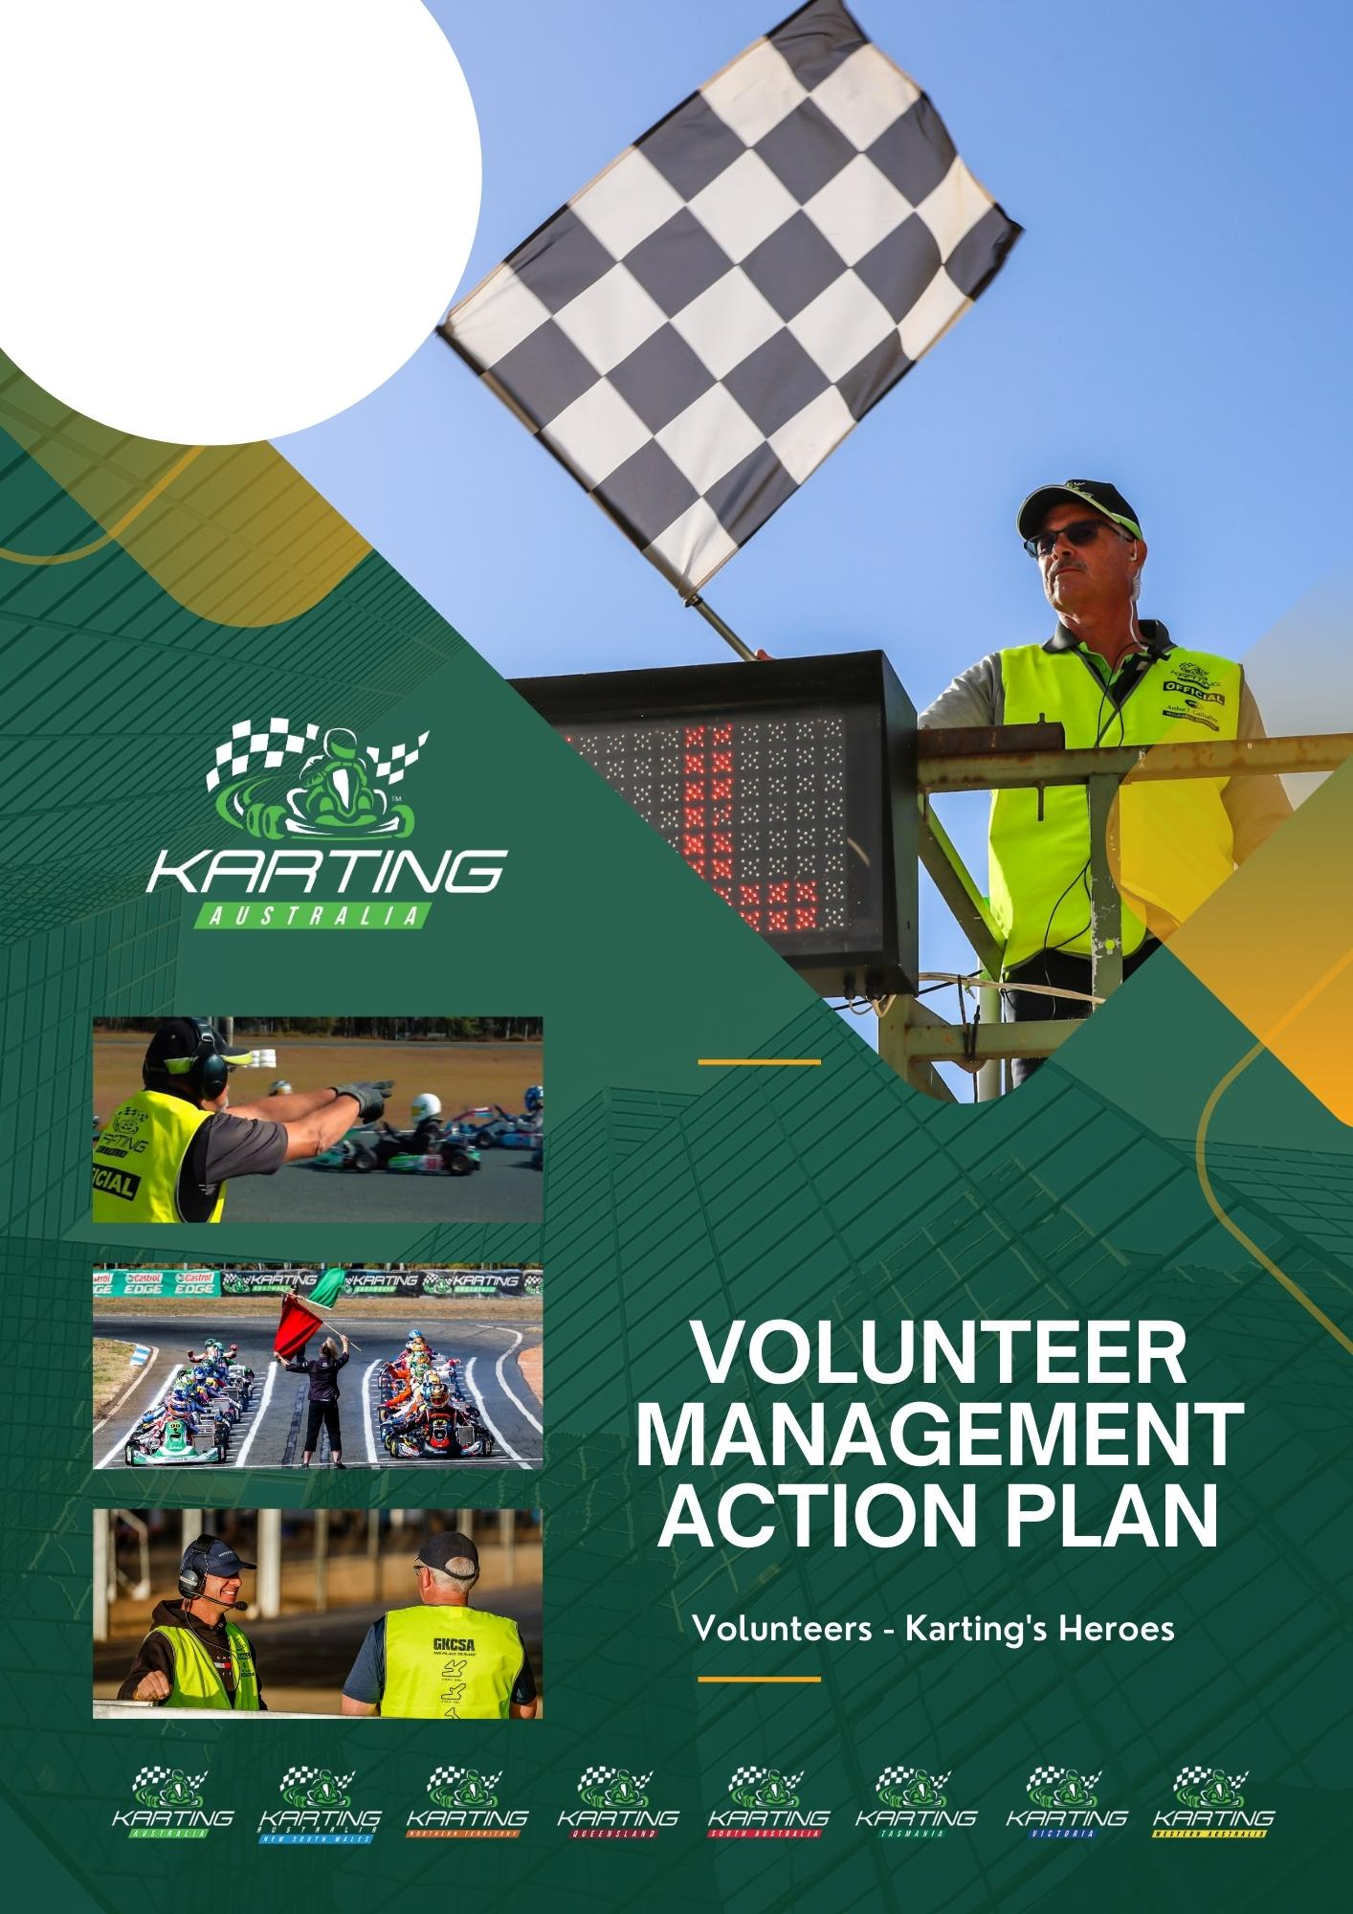
INSERT YOUR
CLUB NAME
INSERT YOUR
CLUB LOGO
HERE
By following this Volunteer Management Action Plan – the V-MAP, the club can ensure a smooth transition of roles, maintain continuity, and foster a culture of mentorship and growth.
INSTRUCTIONS
DESIGNING YOUR V-MAP
XXXX Delete the following Statement and the section of red type from your completed V-MAP XXXX
Please note that this Volunteer Management Action Plan is a customisable tool for Karting Clubs and Member State Associations.
Certain modifications will be needed to align the plan with the unique requirements of each Club and Association.
The following pages are where you will document your Club’s own Volunteer Management Action Plan.
This is what you need to do:
- Read the Volunteer Management Framework and the preceding pages of this Workbook.
- Familiarise yourself with the:
  - Customisable Volunteer Position Descriptions that we have prepared for you and that are available for your use on the Karting Australia website:
https://www.karting.net.au/club-toolkit/volunteers
  - Other volunteer resources that are also in the Club Toolkit.
- Start the discussion about taking up the Volunteer Challenge in your Club.
- Convene a Club Executive / Committee Meeting that is devoted solely to addressing the Volunteer Challenge where you will start to formally address the issue of On-Track (Race Officials) and Off-Track Volunteering in your Club.
- Follow the 7 V-MAP Steps:
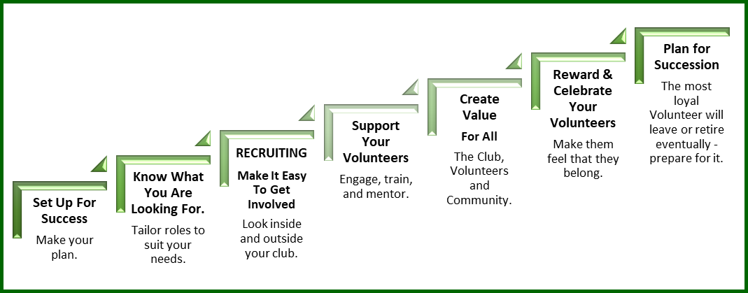
- Document your V-MAP by
  - Selecting your preferred V-MAP template that we have prepared and that suit the size and needs of your Club that start on page 5 herein; and
  - Adding in action points from the “7 Step V-MAP template tables” from the preceding pages.
- Once you have finalised version 1 of you Club’s V-MAP, put it into action. (Your V-MAP will not do you any good unless the Committee and the Volunteer Co-Ordinator (if you appoint one) put it into action.)
- Volunteering MUST be maintained on every Club Executive Club Committee meeting agenda.
- You should always budget for the recruitment, training, recognition, and reward of your Volunteers

NOTE: The Standard Volunteer Management Plans have been provided as a guide only.
Please edit as necessary by referring to the “KA Volunteer Management Framework” and the 7 Steps Tables in

“Volunteer Management Action Plan” workbook to reflect the requirements of your Club.
Select any of the discussion/action points from the tables above and add them to the standard plan that applies to your Club.
About Our Sport and Our Club

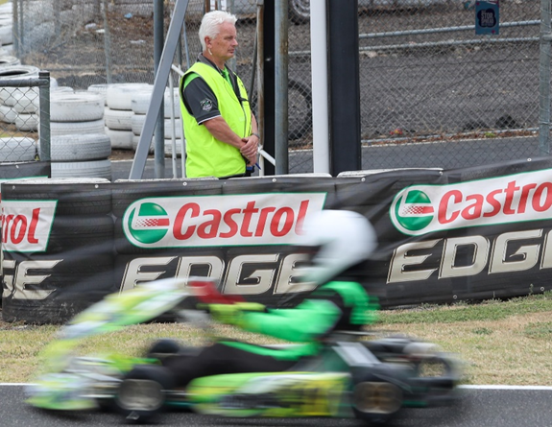
Welcome to the dynamic world of kart racing at the [Club Name] Kart Club! Established in [year], our Club is nestled [number] km from [closest major town]. We offer convenient access to a wide range of accommodation options nearby to ensure a comfortable stay for our members and guests. Currently, our club is home to around [number of members] enthusiastic karters and their families, alongside a flourishing regional membership. We operate as a separate incorporated entity, steered by a committee of dedicated volunteer members. Our affiliation with Karting [State] ties us to the larger Karting Australia community, creating a network of passionate karting enthusiasts across the country.

Our aim is to offer our members top-tier sprint kart racing facilities that ensure safety for drivers, pit crew, Officials and families alike. Our Vision encapsulates an atmosphere of fun, inclusion, and respect, where karting is a fun and welcoming activity for all ages. We prioritise customer satisfaction and maintain a keen focus on safety.

Our Club prides itself on our Values. We are a welcoming, family-friendly, inclusive, fun, and diverse community. Safety, respect, excellence, teamwork, honesty, and trust underline everything we do.

We firmly believe that the strength and evolution of our Club is hinged on our members' active involvement and commitment. As a volunteer-run organisation, we encourage all members to engage more deeply with the club beyond just racing. After all, as a member, you are now part of our team - it is your club!

We host a range of karting competitions and activities, from regular Recreational Events (just for fun) to Club Competition, extending to State level Competition and on a semi-regular basis, we host National Championship, Series and Cup events. Organising large-scale State and national events requires a lot of planning and help from our members, ensuring successful and profitable events.

Maintaining our facilities is a team effort, with track and grounds upkeep taking place at our regular working bees. The more members that lend a hand, the quicker we get the work done, thus minimizing the closure time for the track. Every member's contribution counts, and we expect each one to attend at least one working bee per year.

Join us at the [Club Name] Kart Club, and immerse yourself in a thrilling, inclusive, and satisfying karting experience.

[Signed]
Club President

Our Club/State Details

Club Name
<Insert Full Club Name>

Trading Name
<Insert Trading Club Name If Applicable>

State Association
<Insert Association Name>
Year Established
<Insert Year>
Circuit
<Insert Circuit Name>
Website
<Insert Club Website>
Social Media Accounts
<Insert Club Social Media Accounts>

Club Vision
Karting at <Club Name> is fun, enjoyable, and welcoming for all ages with a focus on safety, respect, inclusion, and customer satisfaction.

Club Values
Welcoming, Family Friendly, Inclusive, Fun, Diverse, Safety 1st, Respect, Excellence, Teamwork, Honesty, and Trust.

Number of Volunteers
Insert Number Of Club Volunteers

Insert Your Club or State Logo Here
Number of Life Members
Insert Number Of Club Life Members

Sponsors
Insert Club Sponsor

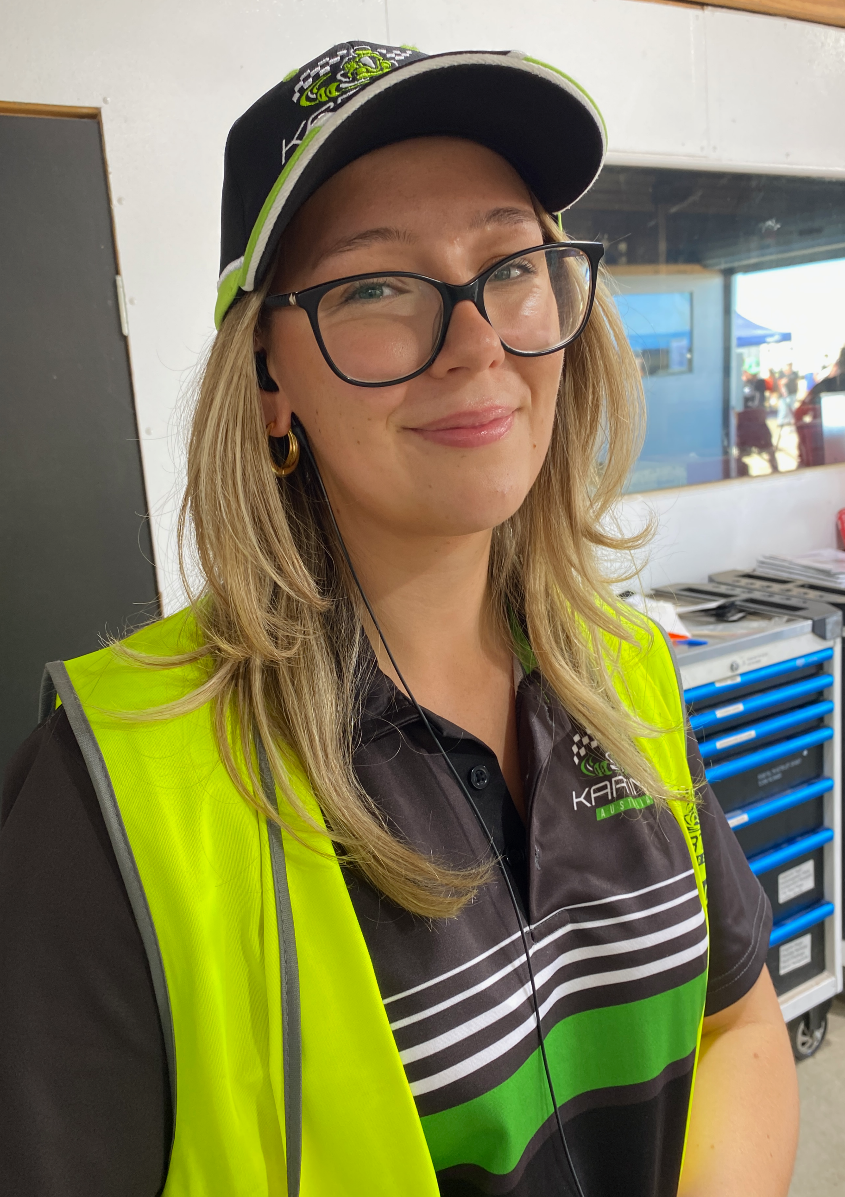
Delete the V-MAPs that you are not using and customise the version that you have selected.
Small Club V-MAP (Fewer than 50 members)
[Karting Club] Volunteer Management Action Plan
1. Introduction (Setting Up For Success)
- Purpose
- To effectively manage and appreciate the volunteers who support the <XYZ> Karting Club.
- Scope
- This plan covers the recruitment, training, appreciation, and retention of volunteers.
- Objectives of the Volunteer Program
- Enhance the club's operations and events.
- Foster a sense of community and teamwork.
- Provide opportunities for members to contribute and develop skills.

2. Volunteer Roles & Responsibilities
(Customise for your Club)
- Determine and then list here the specific roles within the Club that require either paid personnel or or volunteers to undertake the specific duties of the role, including:
  - The statutory roles required by law: President, Secretary (or Public Officer), Treasurer etc.,
  - The roles required by the KA NCRs to be filled:
    - Club Safety Officer – (Refer to NCR, General Rules, Chapter 4)
      - Must successfully complete the Club Safety Officer Course in the KA Officials Academy.
  - The roles that the Club will need to fill to be effective and efficient in organising Race Meetings, (Refer to NCR, General rules Chapters, 5, 6, 7.
    - Race / Competition Secretary (Responsible for organising and preparing for Race Meetings),
      - Event Administration Officers / Committee Members who will form the Organising Committee for Race Meetings,
    - Promotions Officer / Social Media Officer etc
    - Key Race Officials or Officials Officer
  - Any other roles that the Club thinks they need to appoint to share the load and to run the Club efficiently e.g. :
    - Membership Coordinator to manage member registrations and renewals.
    - Equipment Manager to oversee the maintenance and storage of equipment.
- Volunteer Position Descriptions:
  - Select and customise the Position Descriptions for each Volunteer role, detailing responsibilities, time commitment, and any required skills or qualifications.
Template PD’s can be found here: https://www.karting.net.au/club-toolkit/volunteers

3. Recruitment Process
- Advertise/Seek/Find
  - Seek appropriate people to fill the identified roles that need volunteers.
- Promotion
  - Use club's social media, website, and member meetings to advertise volunteer opportunities.
- Selection
  - Interview potential volunteers and match them with suitable roles.
- Screening
  - This ensures both safety and suitability for the role and identifies potential risks
4. SUPPORT YOUR VOLUNTEERS
- Welcome
- Provide new volunteers with a welcome kit that includes:
- A welcome letter
- Club's history, purpose and vision
- Volunteer's position description
- Contact details of key club members
- Orientation
  - Introduce new volunteers to the club's purpose, values, and operations.
- Skill Development
  - Offer training sessions for specific roles (e.g., safety protocols for the Safety Officer).
- Mentorship
- Pair new volunteers with experienced members for guidance.
- Budget
- Allocate appropriate funds to implement critical elements of the plan

5. Create Value
- Regular Communications and Meetings
- Communicate regularly by text, email, and phone
- Conduct bi-monthly volunteer meetings to discuss upcoming events and address concerns.
- Feedback Loop
- Create a system for volunteers to provide feedback and suggestions.
- Code of Conduct:
- Outline expected behaviours and values for all volunteers.
- Safety Protocols:
- Ensure all volunteers are aware of and adhere to safety guidelines.
- Grievance Policy:
- Establish a clear process for addressing any issues or conflicts among volunteers.

6. Reward and Celebrate
- Thank You Events:
- Organise bi-annual events to celebrate and thank volunteers.
- Recognition:
- Highlight a "Volunteer of the Month" on the club's social media and website.
- Perks:
- Offer discounts on club merchandise or free entry to certain events for active volunteers.

7. Plan For Succession
- Succession Planning:
- Identify potential leaders among volunteers for future committee roles.
- Implement Mentor Programs
- Pair up current volunteers with potential successors.
- Check-ins
- Conduct bi-annual one-on-one check-ins with volunteers to discuss their experiences and any potential challenges.

- Communicate
  - Communicate the importance of succession planning to all members.
  - Never be afraid to ask new, current or past members to help out by giving a little bit of their time to the Club.
- Review & Update
- Conduct a review of the V-MAP annually, incorporating feedback and adjusting to the club's evolving needs.
- Conduct an annual survey to gather feedback from volunteers on their experiences.

This plan provides a simple, structured approach for managing volunteers in a small karting club, ensuring their effective engagement, development, and contribution to the club's success.

Medium Club V-MAP (More than 50 and less than 150 members)
[Karting Club] Volunteer Management Action Plan
1. Introduction (Setting Up For Success)
- Purpose
- To effectively manage and appreciate the volunteers who support the XYZ Karting Club.
- Scope
- This plan covers the recruitment, training, appreciation, and retention of volunteers.
- Objectives of the Volunteer Program
- Enhance the club's operations and events and community outreach.
- Foster a sense of community and teamwork and leadership.
- Provide opportunities for members to contribute and develop skills and take on leadership roles.

2. Volunteer Roles & Responsibilities
(Customise for your Club)
- Determine and then list here the specific roles within the Club that require either paid personnel or or volunteers to undertake the specific duties of the role, including:
  - The statutory roles required by law: President, Secretary (or Public Officer), Treasurer etc.,
  - The roles required by the KA NCRs to be filled:
    - Club Safety Officer – (Refer to NCR, General Rules, Chapter 4)
      - Must successfully complete the Club Safety Officer Course in the KA Officials Academy.
  - The roles that the Club will need to fill to be effective and efficient in organising Race Meetings, (Refer to NCR, General rules Chapters, 5, 6, 7.
    - Race / Competition Secretary (Responsible for organising and preparing for Race Meetings),
      - Event Administration Officers / Committee Members who will form the Organising Committee for Race Meetings,
    - Promotions Officer / Social Media Officer etc
    - Key Race Officials or Officials Officer
  - In addition to statutory roles, consider introducing roles that the Club thinks they need to appoint to share the load and to run the Club efficiently e.g. :
    - Membership Coordinator to manage member registrations and renewals.
    - Equipment Manager to oversee the maintenance and storage of equipment.
    - Community Outreach Coordinator: To engage with the local community and schools.
    - Sponsorship Coordinator: To seek and manage club sponsorships.
    - Youth Engagement Officer: To involve younger members in club activities.
- Volunteer Position Descriptions:
  - Select and customise the Position Descriptions for each Volunteer role, detailing responsibilities, time commitment, and any required skills or qualifications.
  - Regularly update position descriptions to reflect the growing needs of a medium-sized club.
Template PD’s can be found here: https://www.karting.net.au/club-toolkit/volunteers

3. Recruitment Process
- Advertise/Seek/Find
  - Seek appropriate people to fill the identified roles that need volunteers.
  - Collaborate with local businesses and schools for potential volunteer partnerships.
- Promotion
  - Use club's social media, website, and member meetings to advertise volunteer opportunities.
  - Host open days or volunteer ‘fairs’ to attract and engage potential volunteers.
- Selection
  - Interview potential volunteers and match them with suitable roles.
  - Introduce a panel-based interview process to ensure a diverse range of volunteers are selected.
- Screening
  - This ensures both safety and suitability for the role and identifies potential risks.
  - Implement advanced screening processes, including reference checks for critical roles.

4. SUPPORT YOUR VOLUNTEERS
- Welcome
  - Provide new volunteers with a welcome kit that includes:
  - A welcome letter
  - Club's history, purpose and vision
  - Volunteer's position description
  - Contact details of key club members
- Orientation
  - Introduce new volunteers to the club's purpose, values, and operations.
  - Organise team-building activities during orientation to foster camaraderie.
- Skill Development
  - Offer training sessions for specific roles (e.g., safety protocols for the Safety Officer).
  - Introduce advanced training sessions, considering the diverse roles in a medium-sized club.
- Mentorship
- Pair new volunteers with experienced members for guidance.
- Organize quarterly mentor-mentee meetups to ensure continuous guidance.
- Budget
- Allocate appropriate funds to implement critical elements of the plan.
- Consider a larger budget allocation for volunteer management, reflecting the club's growth.

5. Create Value
- Regular Communications and Meetings
- Communicate regularly by text, email, and phone
- Conduct bi-monthly volunteer meetings to discuss upcoming events and address concerns.
- Introduce a dedicated communication platform or app (e.g. WhatsApp or Stack Team App) for volunteers.
- Feedback Loop
- Create a system for volunteers to provide feedback and suggestions.
- Implement a more structured feedback mechanism, like quarterly focus group discussions.
- Code of Conduct:
- Outline expected behaviours and values for all volunteers.
- Organise yearly workshops on ethical conduct and club values.
- Safety Protocols:
- Ensure all volunteers are aware of and adhere to safety guidelines.
- Introduce advanced safety training sessions, especially for roles directly involved in karting activities.
- Grievance Policy:
- Establish a clear process for addressing any issues or conflicts among volunteers.
- Set up a dedicated committee or committee member to address volunteer grievances.

6. Reward and Celebrate
- Thank You Events:
- Organise bi-annual events to celebrate and thank volunteers.
- Consider larger-scale events, like an annual volunteer awards night.
- Recognition:
- Highlight a "Volunteer of the Month" on the club's social media and website.
- Introduce a "Volunteer of the Quarter" recognition system.
- Perks:
- Offer discounts on club merchandise or free entry to certain events for active volunteers.

7. Plan For Succession
- Succession Planning:
- Identify potential leaders among volunteers for future committee roles.
- Organise leadership training sessions for potential successors.
- Implement Mentor Programs
- Pair up current volunteers with potential successors.
- Introduce group mentorship programs, where a group of new volunteers is mentored by a senior volunteer.
- Check-ins
- Conduct bi-annual one-on-one check-ins with volunteers to discuss their experiences and any potential challenges.
- Introduce a more structured feedback mechanism during check-ins, like a standardized feedback form.
- Communicate
  - Communicate the importance of succession planning to all members.
  - Never be afraid to ask new, current or past members to help out by giving a little bit of their time to the Club.
  - Organize bi-annual meetings to discuss the importance of succession planning.
- Review & Update
- Conduct a review of the V-MAP annually, incorporating feedback and adjusting to the club's evolving needs.
- Conduct an annual survey to gather feedback from volunteers on their experiences.
- Form a dedicated committee comprising senior volunteers and club members to oversee the bi-annual review and update process.

This plan provides a comprehensive approach for managing volunteers in a medium-sized karting club, ensuring their effective engagement, development, and contribution to the club's success.

Large Club V-MAP (More than 150 members)
[Karting Club] Volunteer Management Action Plan
For A Large Karting Club (more than 150 members)

1. Introduction (Setting Up For Success)
- Purpose
- To effectively manage and appreciate the volunteers who support the XYZ Karting Club.
**Priority Action:**
- Establish a dedicated volunteer management team to oversee the entire volunteer program.
- Scope
- This plan covers the recruitment, training, appreciation, and retention of volunteers.
**Priority Action:**
- Expand the scope to include volunteer career progression within the club.
- Objectives of the Volunteer Program
- Enhance the club's operations and events and community outreach.
- Foster a sense of community and teamwork and leadership.
- Provide opportunities for members to contribute and develop skills and take on leadership roles.
**Priority Action:**
- Introduce a yearly volunteer satisfaction survey to measure the success of the program.

2. Volunteer Roles & Responsibilities
(Customise for your Club)
- Determine and then list here the specific roles within the Club that require either paid personnel or or volunteers to undertake the specific duties of the role, including:
  - The statutory roles required by law: President, Secretary (or Public Officer), Treasurer etc.,
  - The roles required by the KA NCRs to be filled:
    - Club Safety Officer – (Refer to NCR, General Rules, Chapter 4)
      - Must successfully complete the Club Safety Officer Course in the KA Officials Academy.
  - The roles that the Club will need to fill to be effective and efficient in organising Race Meetings, (Refer to NCR, General rules Chapters, 5, 6, 7.
    - Race / Competition Secretary (Responsible for organising and preparing for Race Meetings),
      - Event Administration Officers / Committee Members who will form the Organising Committee for Race Meetings,
    - Promotions Officer / Social Media Officer etc
    - Key Race Officials or Officials Officer
  - In addition to statutory roles, consider introducing roles that the Club thinks they need to appoint to share the load and to run the Club efficiently e.g. :
    - Membership Coordinator to manage member registrations and renewals.
    - Equipment Manager to oversee the maintenance and storage of equipment.
    - Community Outreach Coordinator: To engage with the local community and schools.
    - Sponsorship Coordinator: To seek and manage club sponsorships.
    - Youth Engagement Officer: To involve younger members in club activities.
**Priority Action:**
Create a volunteer advisory committee to provide insights and feedback on club operations.
- Volunteer Position Descriptions:
  - Select and customise the Position Descriptions for each Volunteer role, detailing responsibilities, time commitment, and any required skills or qualifications.
  - Regularly update position descriptions to reflect the growing needs of a medium-sized club.
**Priority Action:**
Introduce an annual review process for all position descriptions to ensure they remain relevant.
Template PD’s can be found here: https://www.karting.net.au/club-toolkit/volunteers

3. Recruitment Process
- Advertise/Seek/Find
  - Seek appropriate people to fill the identified roles that need volunteers.
  - Collaborate with local businesses and schools for potential volunteer partnerships.
**Priority Action:**
Partner with local colleges for internship programs to attract young talent.
- Promotion
  - Use club's social media, website, and member meetings to advertise volunteer opportunities.
  - Host open days or volunteer ‘fairs’ to attract and engage potential volunteers.
**Priority Action:**
Develop a dedicated section on the club's website for volunteer opportunities and testimonials.
- Selection
  - Interview potential volunteers and match them with suitable roles.
  - Introduce a panel-based interview process to ensure a diverse range of volunteers are selected.
**Priority Action:**
Implement a skills assessment test during the selection process.
- Screening
  - This ensures both safety and suitability for the role and identifies potential risks.
  - Implement advanced screening processes, including reference checks for critical roles.
**Priority Action:**
Introduce periodic re-screening for long-term volunteers to ensure continued suitability.

4. SUPPORT YOUR VOLUNTEERS
- Welcome
  - Provide new volunteers with a welcome kit that includes:
  - A welcome letter
  - Club's history, purpose and vision
  - Volunteer's position description
  - Contact details of key club members
**Priority Action:**
Introduce a digital onboarding platform for new volunteers such as Better Impact https://www.betterimpact.com.au/
- Orientation
  - Introduce new volunteers to the club's purpose, values, and operations.
  - Organise team-building activities during orientation to foster camaraderie.
**Priority Action:**
Develop an orientation video showcasing club operations and volunteer testimonials.
- Skill Development
  - Offer training sessions for specific roles (e.g., safety protocols for the Safety Officer).
  - Introduce advanced training sessions, considering the diverse roles in a medium-sized club.
**Priority Action:**
Collaborate with external groups including the State Association and/or karting Australia for specialised training programs.
- Mentorship
- Pair new volunteers with experienced members for guidance.
- Organize quarterly mentor-mentee meetups to ensure continuous guidance.
**Priority Action:**
Introduce a mentorship certification program for senior volunteers.

- Budget
- Allocate appropriate funds to implement critical elements of the plan.
- Consider a larger budget allocation for volunteer management, reflecting the club's growth.
**Priority Action:**
Allocate funds specifically for volunteer appreciation and rewards.

5. Create Value -
- Regular Communications and Meetings
- Communicate regularly by text, email, and phone
- Conduct bi-monthly volunteer meetings to discuss upcoming events and address concerns.
- Introduce a dedicated communication platform or app (e.g. WhatsApp or Stack Team App) for volunteers.
**Priority Action:**
Implement a monthly newsletter exclusively for volunteers.
- Feedback Loop
- Create a system for volunteers to provide feedback and suggestions.
- Implement a more structured feedback mechanism, like quarterly focus group discussions.
- Code of Conduct:
- Outline expected behaviours and values for all volunteers.
- Organise yearly workshops on ethical conduct and club values.
- Safety Protocols:
- Ensure all volunteers are aware of and adhere to safety guidelines.
- Introduce advanced safety training sessions, especially for roles directly involved in karting activities.
**Priority Action:**
Collaborate with local law enforcement for safety and emergency response training.
- Grievance Policy:
- Establish a clear process for addressing any issues or conflicts among volunteers.
- Set up a dedicated committee or committee member to address volunteer grievances.
**Priority Action:**
Introduce an anonymous online grievance submission portal.

6. Reward and Celebrate
- Thank You Events:
- Organise bi-annual events to celebrate and thank volunteers.
- Consider larger-scale events, like an annual volunteer awards night.
**Priority Action:**
Collaborate with local businesses for sponsorship and rewards for outstanding volunteers.
- Recognition:
- Highlight a "Volunteer of the Month" on the club's social media and website.
- Introduce a "Volunteer of the Quarter" recognition system.
**Priority Action:**
Introduce a digital badge system for volunteers to showcase their achievements on social platforms.
- Perks:
- Offer discounts on club merchandise or free entry to certain events for active volunteers.
**Priority Action:**
Offer exclusive club merchandise for active volunteers.

7. Plan For Succession
- Succession Planning:
- Identify potential leaders among volunteers for future committee roles.
- Organise leadership training sessions for potential successors.
**Priority Action:**
Develop a leadership pipeline program to identify and groom future leaders.
- Implement Mentor Programs
- Pair up current volunteers with potential successors.
- Introduce group mentorship programs, where a group of new volunteers is mentored by a senior volunteer.
- Check-ins
- Conduct bi-annual one-on-one check-ins with volunteers to discuss their experiences and any potential challenges.
- Introduce a more structured feedback mechanism during check-ins, like a standardized feedback form.
**Priority Action:**
Implement a digital platform for tracking volunteer progress and feedback.
- Communicate
  - Communicate the importance of succession planning to all members.
  - Never be afraid to ask new, current or past members to help out by giving a little bit of their time to the Club.
  - Organize bi-annual meetings to discuss the importance of succession planning.
**Priority Action:**
Develop a succession planning toolkit for easy transition of roles.
- Review & Update
- Conduct a review of the V-MAP annually, incorporating feedback and adjusting to the club's evolving needs.
- Conduct an annual survey to gather feedback from volunteers on their experiences.
- Form a dedicated committee comprising senior volunteers and club members to oversee the bi-annual review and update process.
**Priority Action:**
Organise a yearly volunteer summit to discuss the V-MAP and gather feedback.

This enhanced plan provides a comprehensive approach for managing volunteers in a large karting club, ensuring their effective engagement, development, and contribution to the club's success.

APPENDIX 1 - CLUB EXECUTIVE AND GENERAL COMMITTEE
INSERT COMMITTEE ROLES AND OFFICE BEARER NAMES AND CONTACT DETAILS
Executive Committee | Name Surname | Contact email | Contact phone
President
Vice President
Executive officer
Secretary
Treasurer
Club Safety Officer
SKA Delegate
Deputy SKA Delegate
Senior Vice President
ADD OTHER
ADD OTHER
ADD OTHER
ADD OTHER
General Committee Members | Name Surname | Contact email | Contact phone
KOMP Officer
Volunteer Coordinator
Officials Coordinator
Child Safeguarding Officer/MPIO
Canteen/Bar Manager
Awards Committee
Website/Socials
Fundraising/grants
Event Promoter
ADD OTHER
ADD OTHER
ADD OTHER
ADD OTHER
ADD OTHER
ADD OTHER
ADD OTHER
ADD OTHER
ADD OTHER
ADD OTHER

APPENDIX 2 – OFF-TRACK VOLUNTEER POSITION DESCRIPTIONS
INSERT THE POSITION DESCRIPTIONS OF YOUR OFF-TRACK VOLUNTEERS HERE
Template PD’s can be found here: https://www.karting.net.au/club-toolkit/volunteers

APPENDIX 3 ON-TRACK VOLUNTEER (LICENCED AND GRADED RACE OFFICIALS)
REFER TO NCR’s GENERAL RULES CHAPTER 7 – RACE OFFICIALS, POLICY P25 – OFFICIAILS LICENCE POLICY and P24 KARTING ACTIVITY CONTROLLER POLICY.
RACE OFFICIAL ROLES
The list of Race Officials and the Accredited Officiating Disciplines include:
STEWARDS (Event Control)
- Steward
RACE MANAGEMENT OFFICIALS (Event Command)
- Race Director | - Race Secretary | - Clerk of the Course (including Assistants)
- Starter | - Race Prosecutor | - Chief Timekeeper and Timekeeper
- Pit Marshal | - Grid Marshal | - Officials (Stewards) Secretary
- Flag Marshal / Safety Light Operator
TECHNICAL OFFICIALS (Scrutineers)
- Chief Scrutineer | - Scrutineer | - Tyre Tester
- Scale Marshal | - Fuel Tester | - Noise Control Marshal

Minimum Requirements for Race Officials - Refer:
https://www.karting.net.au/wp-content/uploads/2023/12/P25-Officials-Licence-Policy-Updated-13-November-2023-Clean.pdf

RACE OFFICIALS’ PROGRESSION PATHWAY
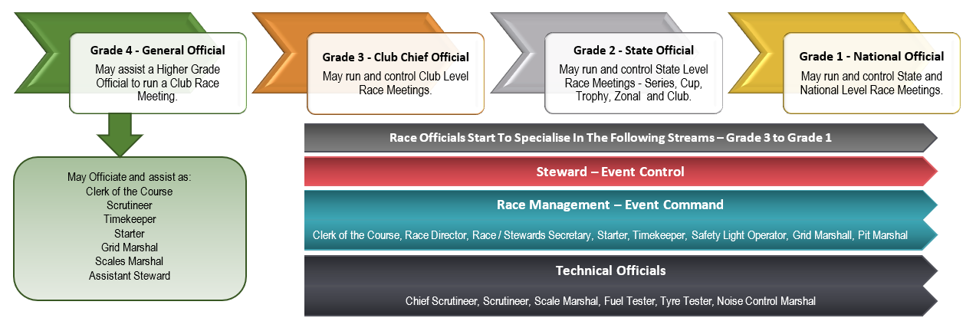

APPENDIX 4 - MINIMUM MEETING REQUIREMENTS FOR OFFICIALS
The Club Officials Coordinator is responsible for ensuring minimum required officials are available for each race/event organised. The following information provides a guide to what this may involve from Club Competition through State Level Events to National Championship Meetings.
To meet minimum event safety requirements the following applies:
 | OFFICIAL  Competition type | CHIEF STEWARD | STEWARD | CLERK OF THE COURSE (COC) | ASSISTANT COC | CHIEF SCRUTINEER | SCRUTINEER | TIMEKEEPER
SOCIAL/  RECREATION | NON-COMPETITIVE | Karting Activity Controller (KAC)
CLUB | CLUB COMPETITION
STATE & ZONAL | STATE CUP  STATE SERIES  STATE TROPHY ZONAL COMPETITION
NATIONAL | STATE CHAMPIONSHIP
 | NATIONAL CHAMPIONSHIP NATIONAL SERIES  NATIONAL CUP |  |  | + Race Director
Colours: Any, Level 4, Level 3, Level 2, Level 1

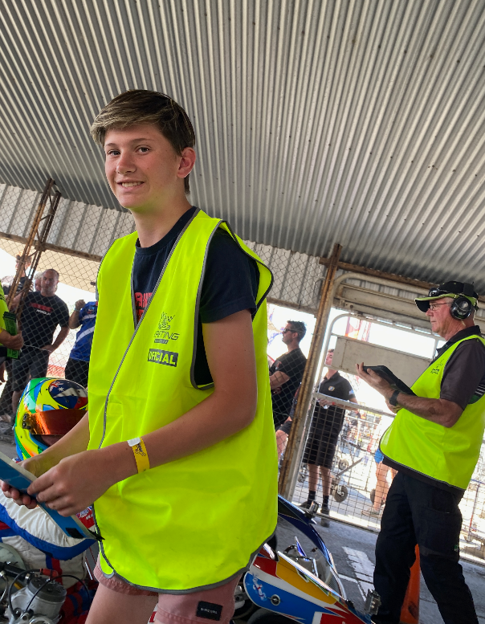
APPENDIX 5 - JUNIOR OFFICIALS
We can find a role for you no matter whether you are young or older.
Minors can become officials too from the age of 14 years old.
Refer: https://www.karting.net.au/wp-content/uploads/2019/11/P26-Junior-Officials-Policy.pdf
Junior officials must be supervised by another official, 18 years or older who holds a current valid KA Officials Licence
Encouraging juniors to officiate is a great way to introduce them to volunteering at a young age and keep them in the sport. Junior Officials can also be non-racing family members looking for another way to get involved in motorsports.

SAFETY FIRST
All Junior Officials must attend an official briefing and be verbally briefed on the day by a senior official. They must be made aware of whom they are responsible to; and safety measures related to the activity.
Junior Officials are not permitted to attend incidents on the Track.
APPENDIX 6 - VOLUNTEER RACE OFFICIALS RECORD FORM
Official Role | Level (Grade) | First Name  Surname | WWC / References | Training achieved/required/requested | Club/State/National events attended | Licence number
Choose an item. | Choose an item.
Choose an item. | Choose an item.
Choose an item. | Choose an item.
Choose an item. | Choose an item.
Choose an item. | Choose an item.
Choose an item. | Choose an item.
Choose an item. | Choose an item.
Choose an item. | Choose an item.
Choose an item. | Choose an item.
Choose an item. | Choose an item.
Choose an item. | Choose an item.
Choose an item. | Choose an item.
Choose an item. | Choose an item.
Choose an item. | Choose an item.
Choose an item. | Choose an item.

APPENDIX 7 - NEW MEMBER COORDINATOR/VOLUNTEER COORDINATOR/VOLUNTEER COMMITTEE RESPONSIBILITIES
The New Member Coordinator/Volunteer Coordinator/Volunteer Committee plays a vital role in ensuring the club always have enough volunteers. Being able to agree on the responsibilities of this role in advance means the expectations are clear and the person taking on the role can feel organised and focused on what needs to be done, and when, and by whom.

RESPONSIBILITIES
PRE-SEASON | SEASON | POST SEASON

APPENDIX 8 – OFF-TRACK VOLUNTEER ENGAGEMENT RECORD FORM
Keeping records is an important part of compliance, and knowing who is volunteering, in which role(s) and when. Sometimes, the need to keep records is a State law requirement. Having accurate club records means everyone involved knows what everyone else has committed to for the season. This is also a great way to track buddy’s/mentors and succession planning.
Role | Date commenced | Name Surname | Phone | Email | WWC / References | Training required/  requested | Mentor/Buddy  /Successor | Licence number
OFF THE TRACK
President
Vice President
Secretary
Treasurer
Club Safety Officer
SKA Delegate
Deputy SKA Delegate
Senior Vice President
Club licensing officer
Volunteer Coordinator
Officials Coordinator
Child Safeguarding Officer/MPIO
Canteen/Bar Manager
Awards Committee
Website/Socials
Fundraising/grants
Organising Committee
Organising Committee
Casual volunteers
Insert additional role
Insert additional role
Insert additional role

APPENDIX 9 -RACE OFFICIAL VOLUNTEER ENGAGEMENT RECORD FORM
Role | Date commenced | Name Surname | Phone | Email | WWC / References | Training required/  requested | Mentor/Buddy  /Successor | Licence number
ON THE TRACK
Stewards
Race Director
Race Secretary
Clear of the Course
Starter
Race Prosecutor
Chief Timekeeper/
Timekeeper
Pit Marshall
Grid Marshall
Officials Secretary
Flag Marshall/
Safety Light Operator
Chief Scrutineer
Scrutineer
Tyre Tester
Scale Marshall
Fuel Tester
Noise Control Marshall
Announcer
Assistant Race Official
Observer
Secretary of the Meeting
Insert additional role
Insert additional role

